**SALESFORCE CRM PROJECT**

**PROJECT NAME : TO SUPPLY LEFTOVER FOOD TO POOR**

**PROJECT OVERVIEW :**

This project aims to streamline the process of leftover food distribution using salesforce.

* **Goal:** To ensure that surplus food is effectively redistributed, minimizing waste and helping the hungry.
* **Impact:** Contributes to waste reduction, addresses hunger, and enhances the management of collection points, assignments, and volunteers.
* **Technology:**  Salesforce tools are used for handling records, automating workflows, and visualizing key data to enable smooth execution.

**OBJECTIVE :**

This project sets out clear, measurable aims to bring both social and operational improvements.

Business Goals :

* + Combat social challenges such as food waste and hunger.
  + Improve operational efficiency, openness, and responsibility.

Deliverables include:

* Custom Salesforce objects like Drop-off Point, Task, Volunteer, and Execution Details.
* Reports and dashboards for operational insights.
* Workflow automation to streamline activities.

**PHASE – 1 : Requirement Analysis & Planning**

PROBLEM STATEMENT : According to global food security reports, millions of people suffer from hunger every day, while a significant amount of edible food is wasted. Recognizing this imbalance, we decided to create a platform—**Food Connect**—to act as a digital bridge between food donors and those in need.

SOLUTION : The **Food Connect** app provides a simple way for people to contribute and help feed others. It introduces solutions to various issues in the food redistribution process:

* It builds a community of volunteers from different regions, enabling the app to serve people across the nation.
* The platform allows individuals to report any surplus food they have and are willing to donate.
* Once a report is submitted, a nearby volunteer is instantly notified with the location details.
* That volunteer collects the food and delivers it to the closest distribution point to ensure it reaches the people in need.

OBJECTIVE :

The main goals and objectives of this project are :

* Tackling problems like food wastage and hunger.
* Ensuring everyone has access to a basic necessity – food.
* Raising awareness about responsible food usage and distribution.

**PHASE – 2 : Salesforce Development – Backend & Configurations**

STEP – 1 : Begin by visiting <https://developer.salesforce.com/signup> to create a Salesforce Developer account. This account forms the foundation for the project setup. Once registered, you’ll gain access to the Salesforce homepage.

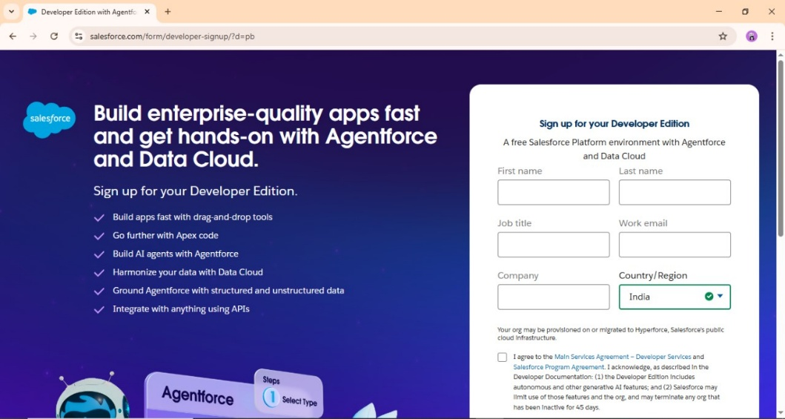

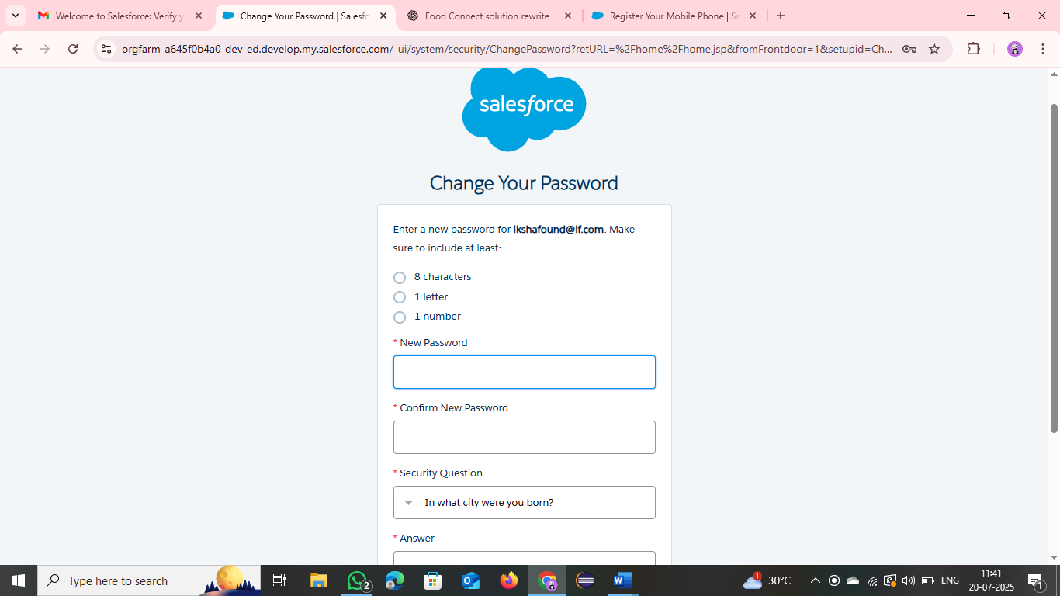

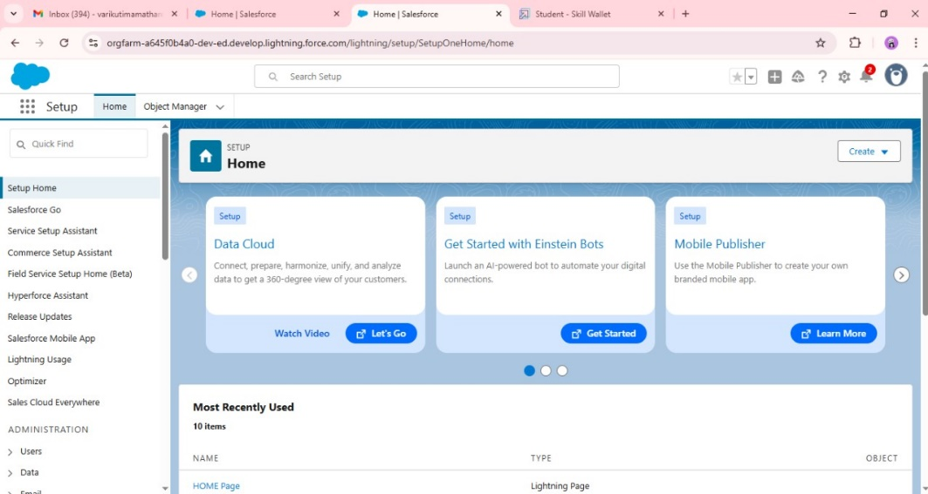

STEP – 2 : The next step involves creating custom objects and adding relevant fields. These fields are categorized based on their roles—such as donations, volunteers, drop-off points, and execution information.

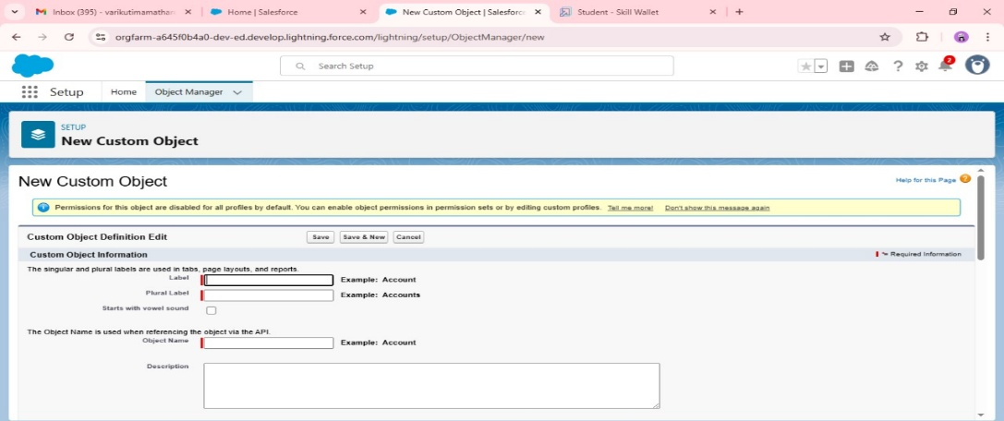

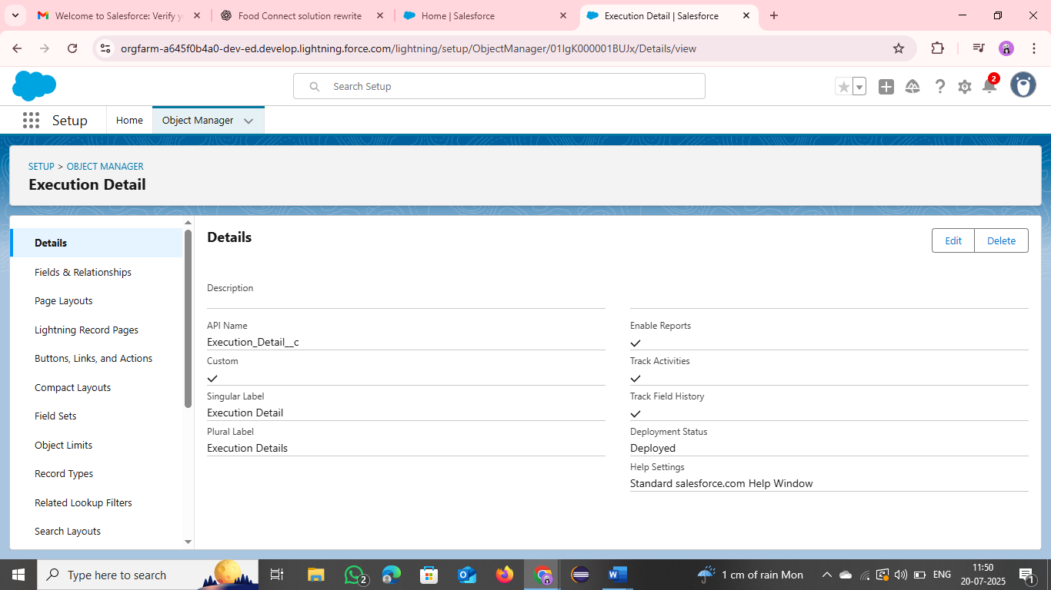

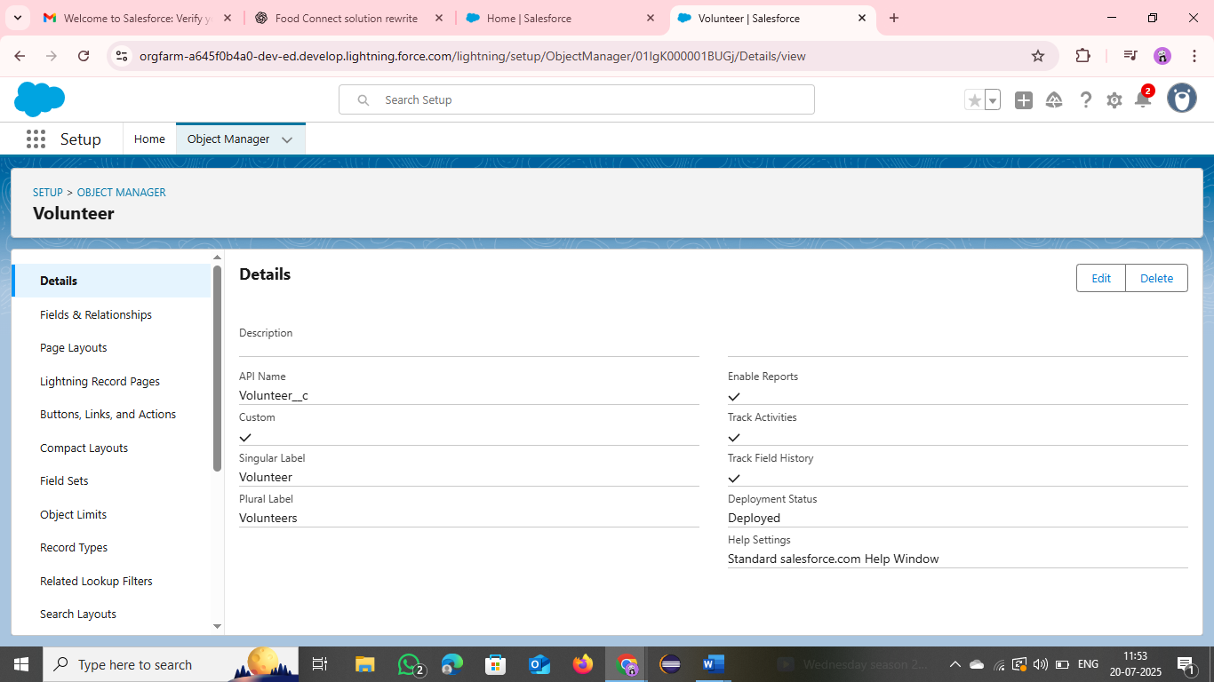

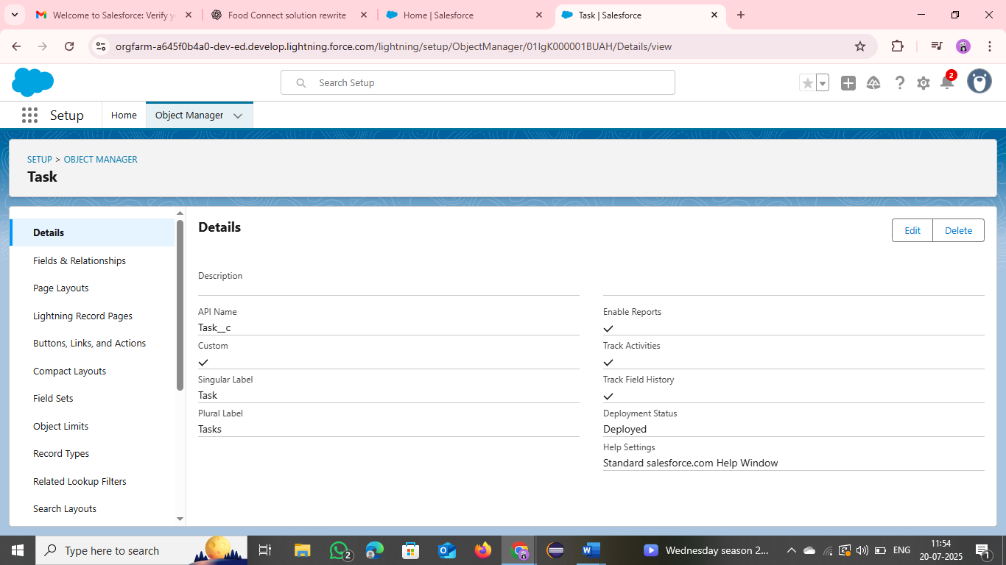

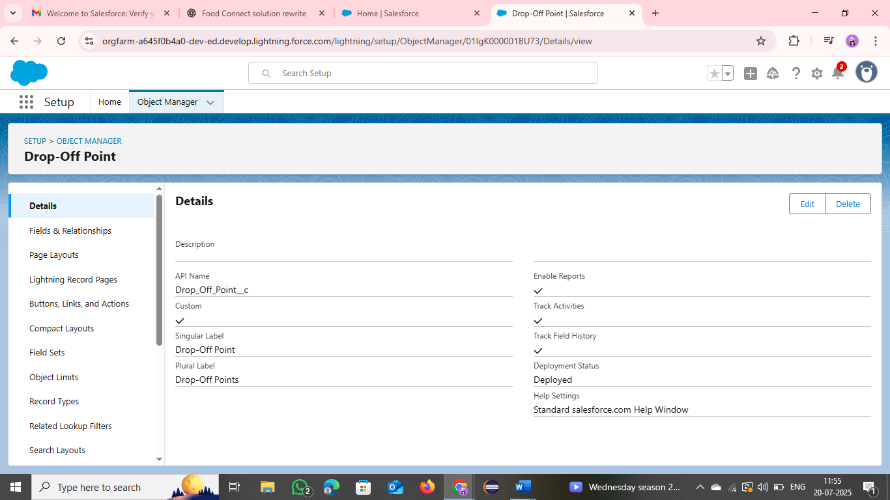

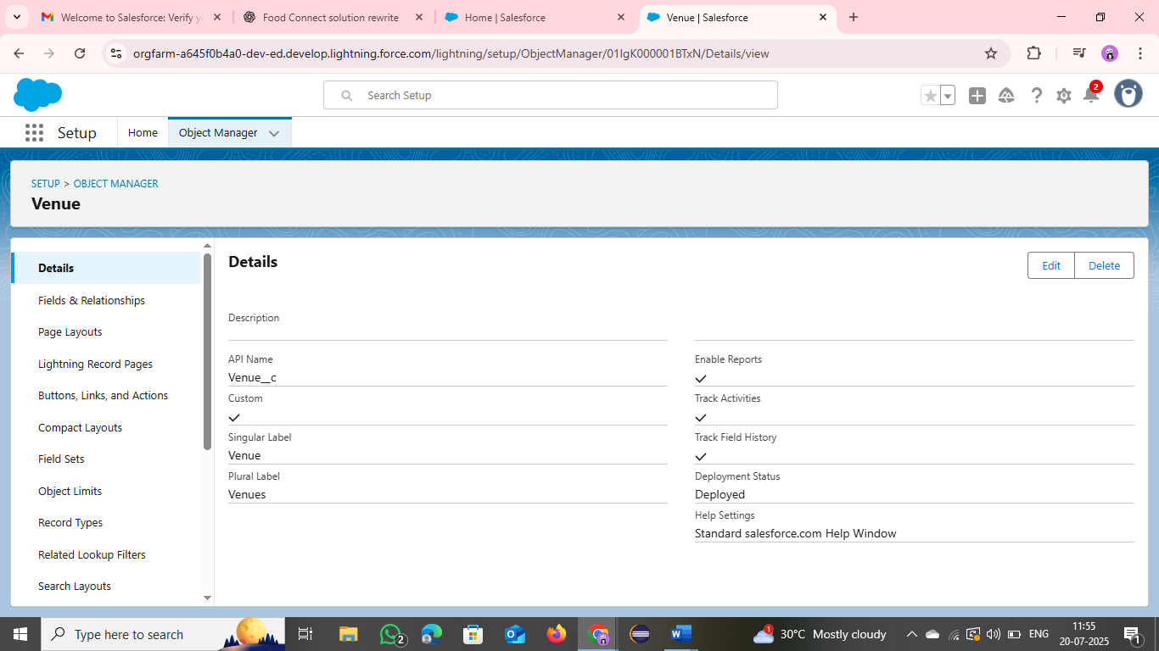

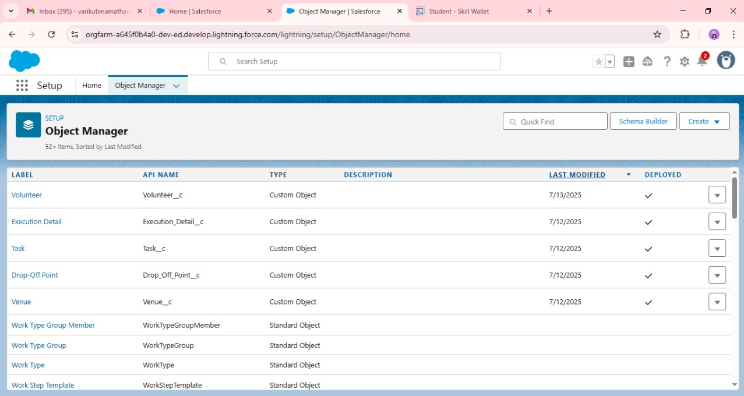

STEP – 3 : Develop a **Flow** called "Venue Form Flow" using Salesforce Flow Builder. This form captures all relevant data entries in one place—volunteer details, donation info, location, and timing—making record-keeping centralized and user-friendly.

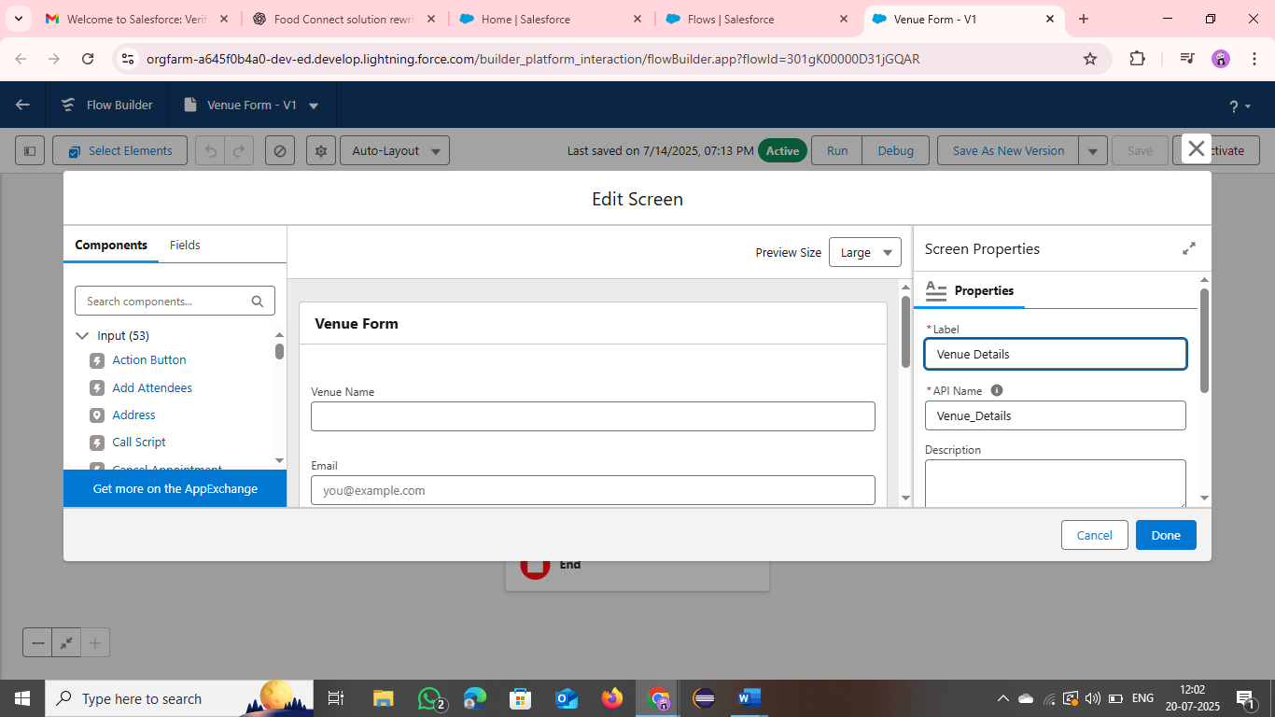

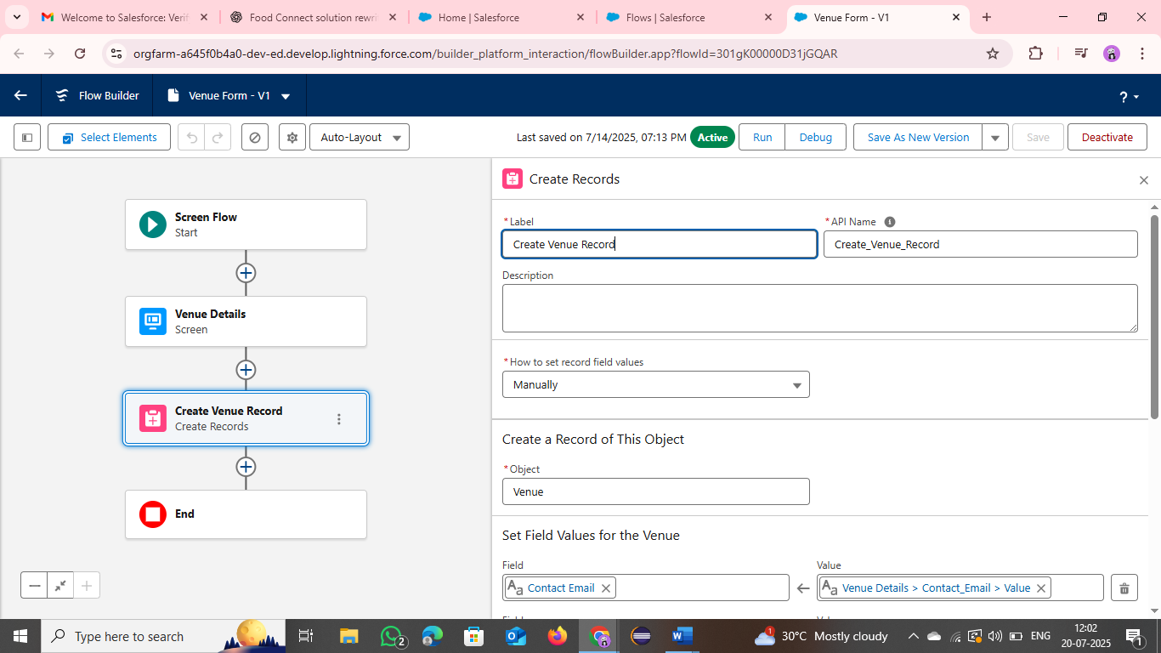

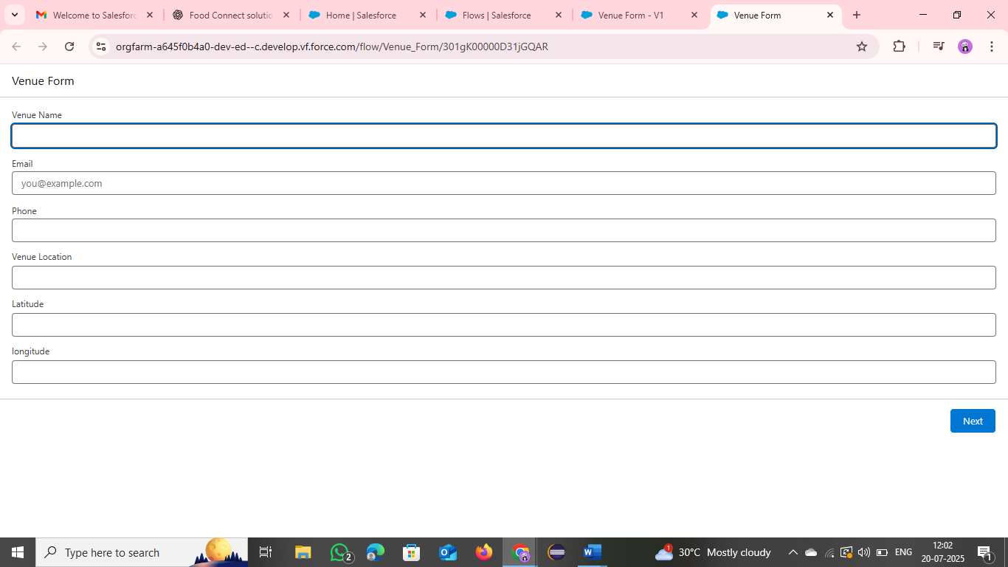

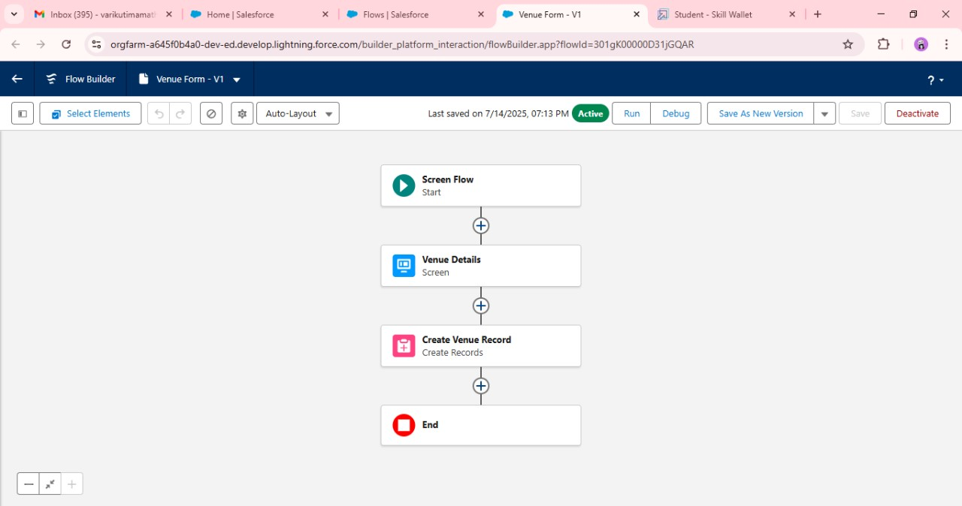

Step – 4:A trigger is developed in this step to handle the logic and actions related to drop-off point operations within the app.

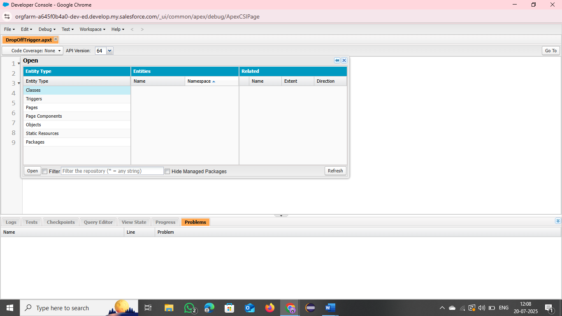

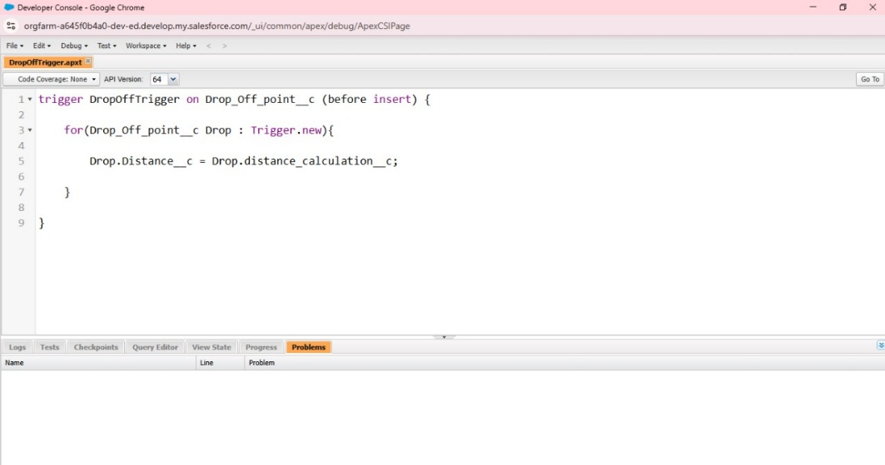

**PHASE – 3 : UI / UX Development & Customization :**

STEP – 1:Design a Lightning App using the **Lightning App Builder**. This serves as the front-end interface for end-users, with intuitive navigation and visual appeal to engage donors and volunteers.

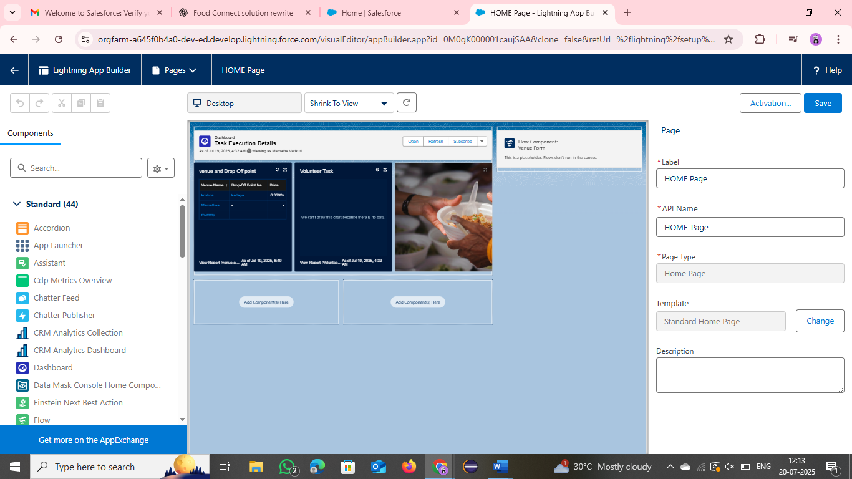

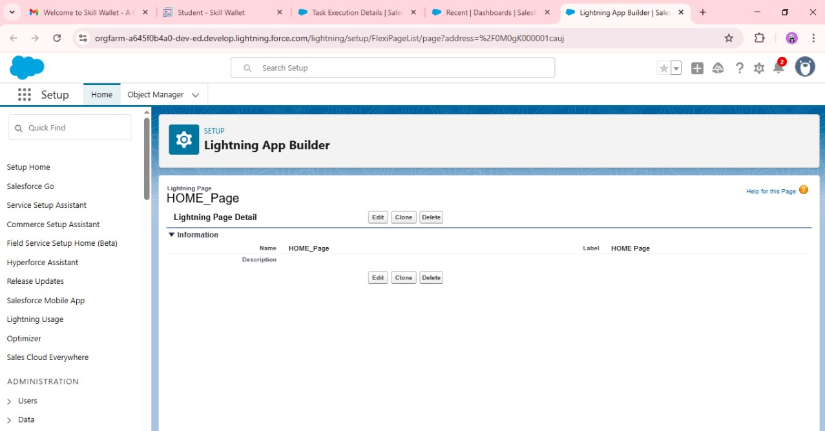

STEP – 2 : Reports are generated at this stage. They help collect and present vital app data and the fields associated with them. These reports are essential for tracking and analysis.

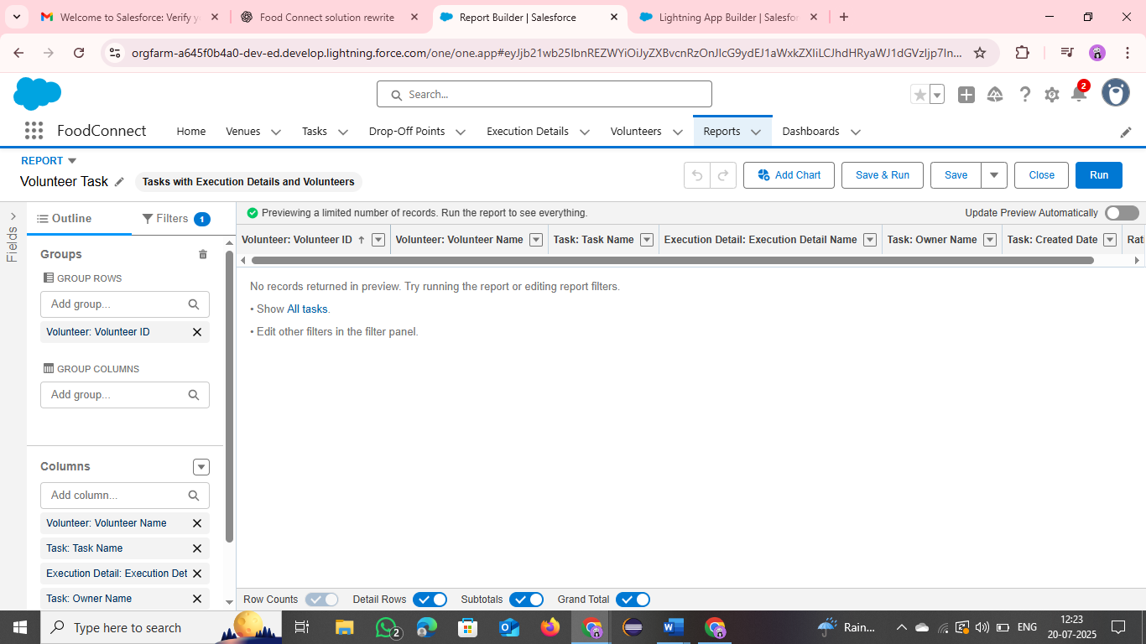

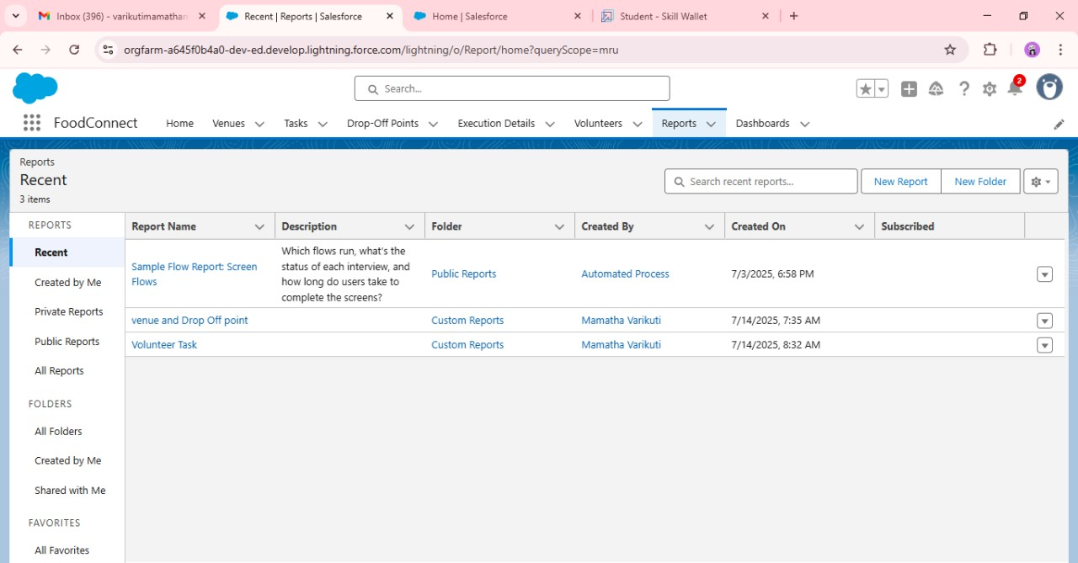

Step 3: Two types of dashboards are created.

* The Organizational Dashboard provides a summary of activities and integrates key reports
* The Task-Execution Dashboard, which also functions as the homepage, offers a personalized view of assigned tasks and updates. One dashboard remains private while the other serves public needs.

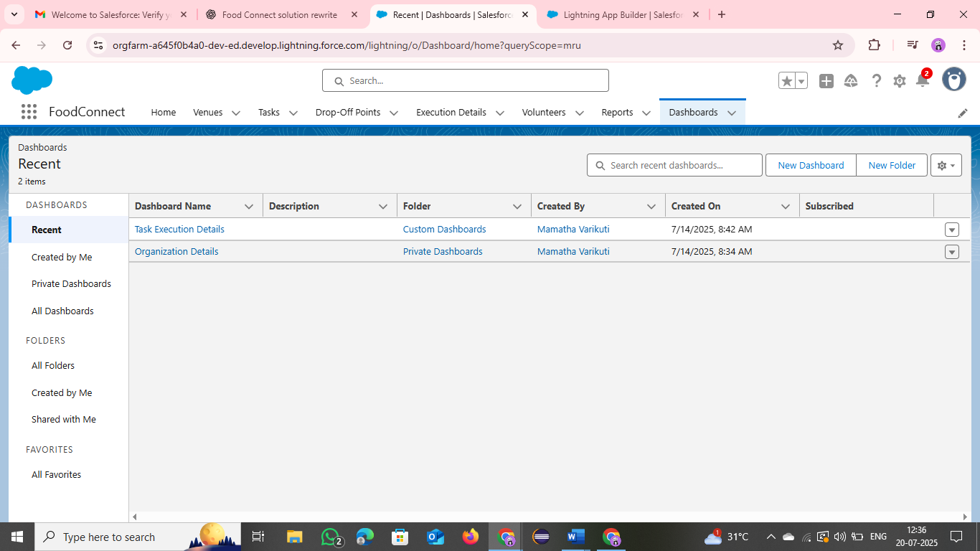

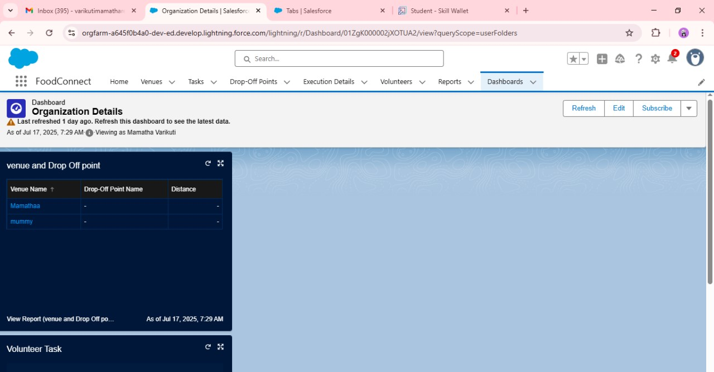

**PHASE – 4 : Data Migration , Testing & Security :**

With the structure of the application complete, it’s time to add data, run tests, and set up proper security measures.

* Enter test data using the venue form and check whether all fields are accepting valid input.
* Verify the system for any bugs, errors, or misbehaving values.
* Security settings and permissions are configured to protect records and ensure that data flows are not compromised.

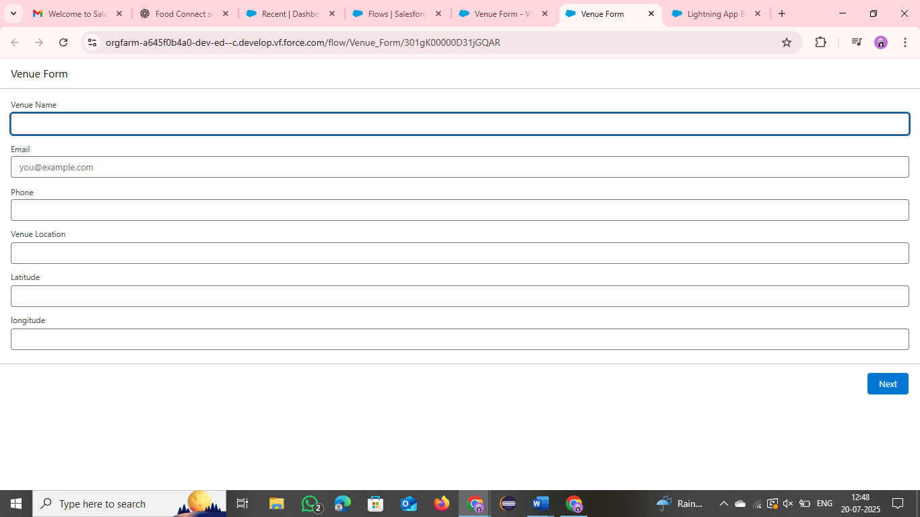

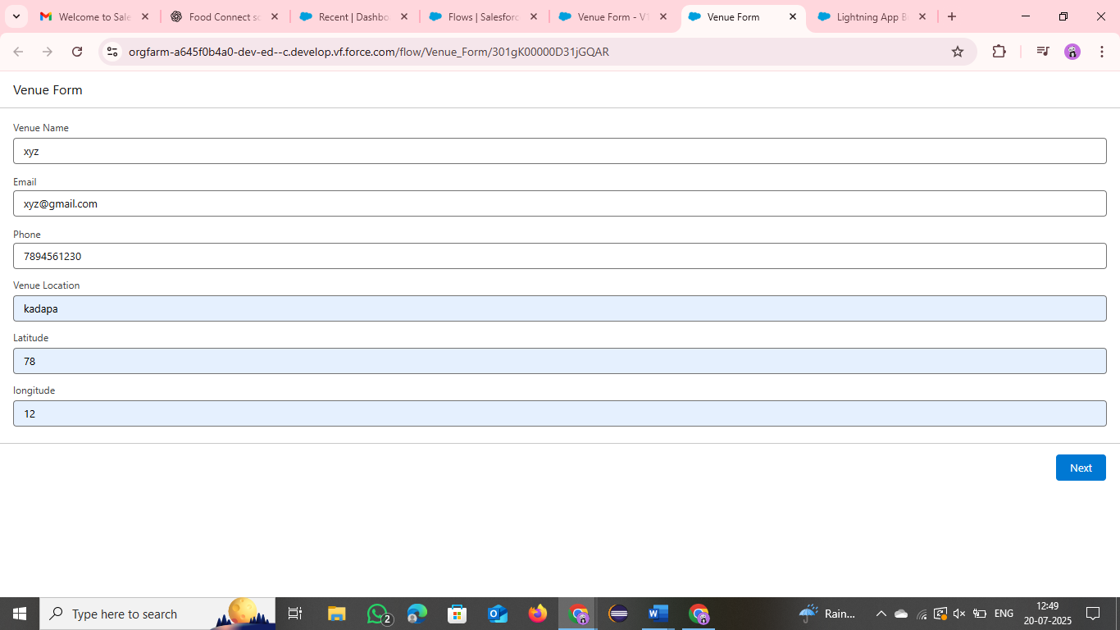

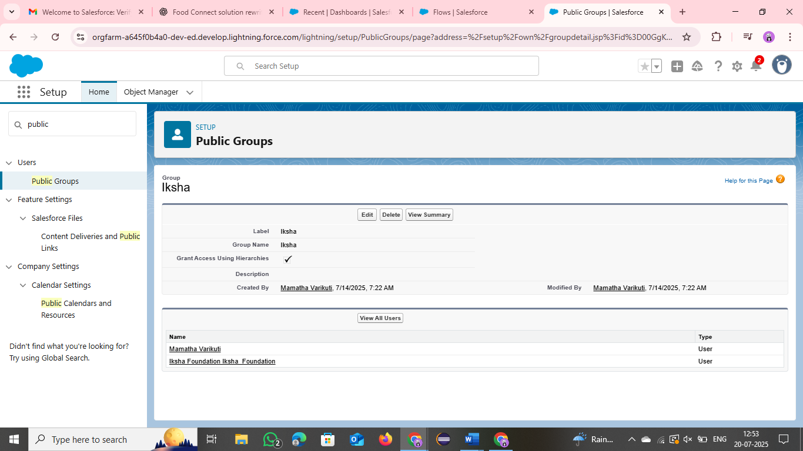

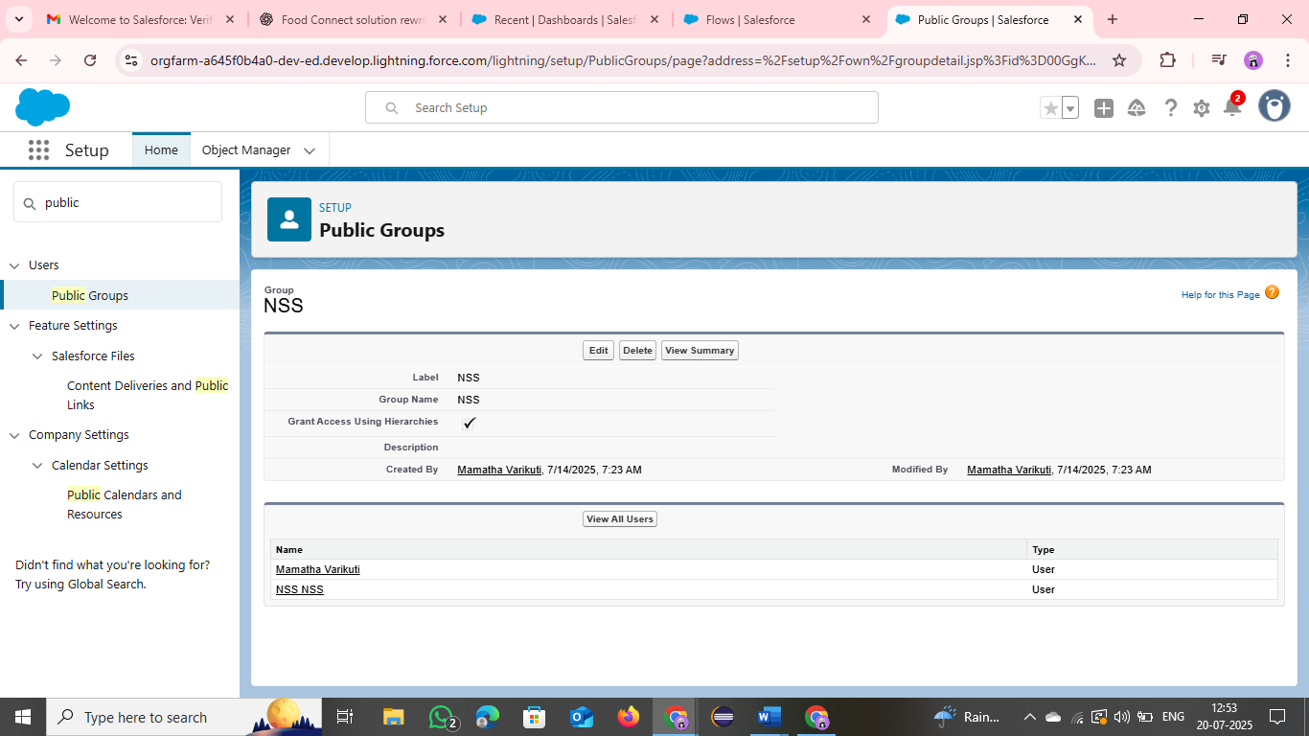

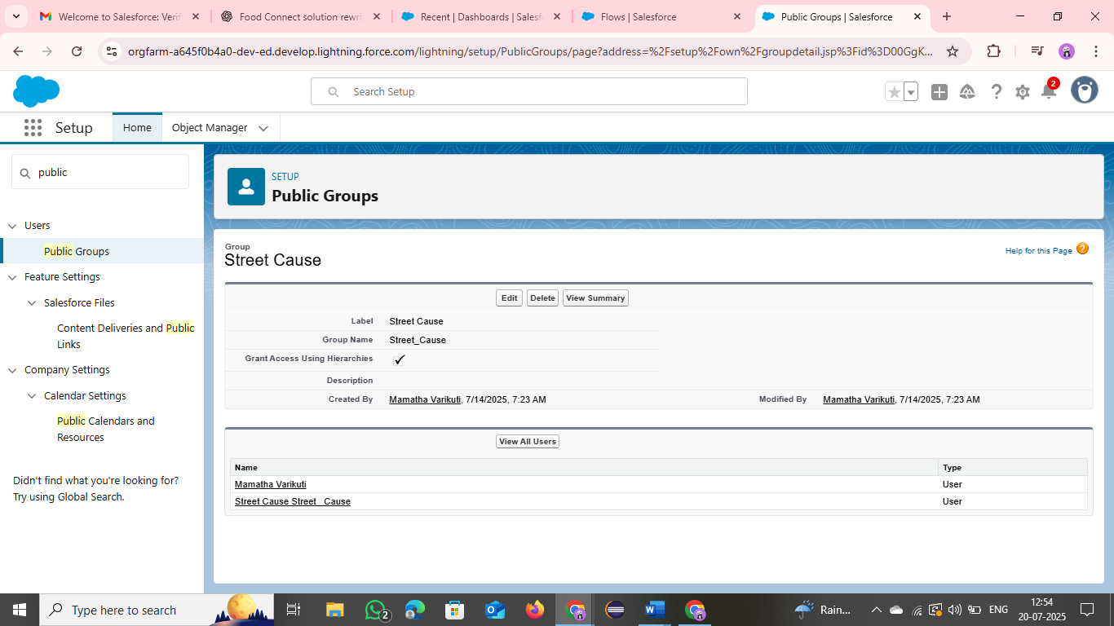

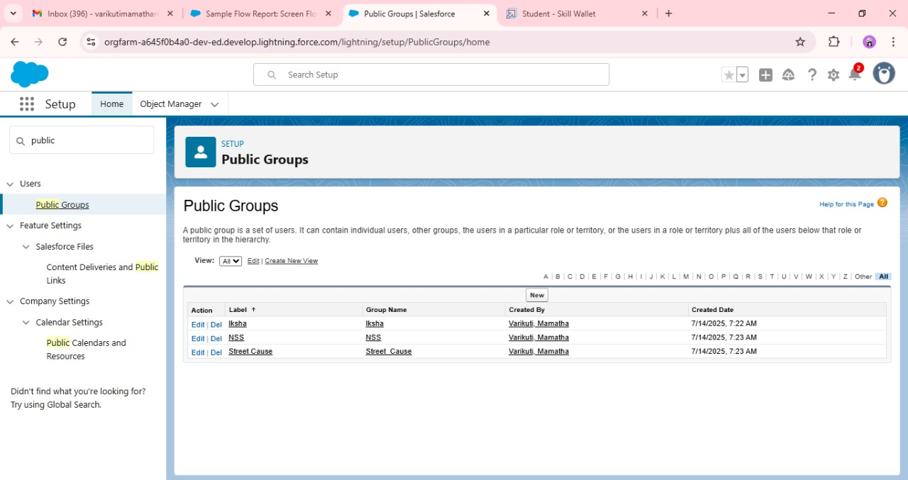

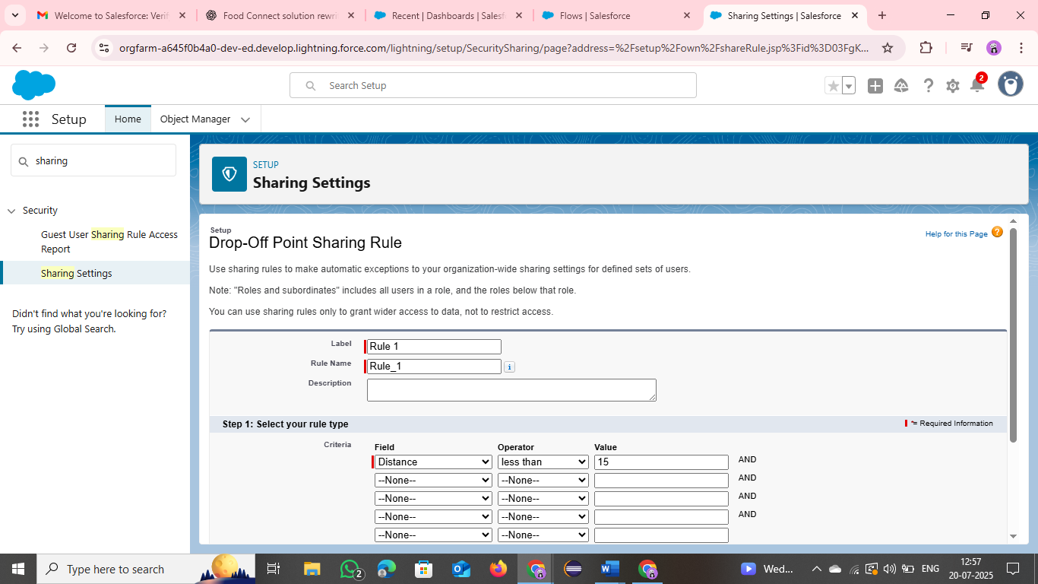

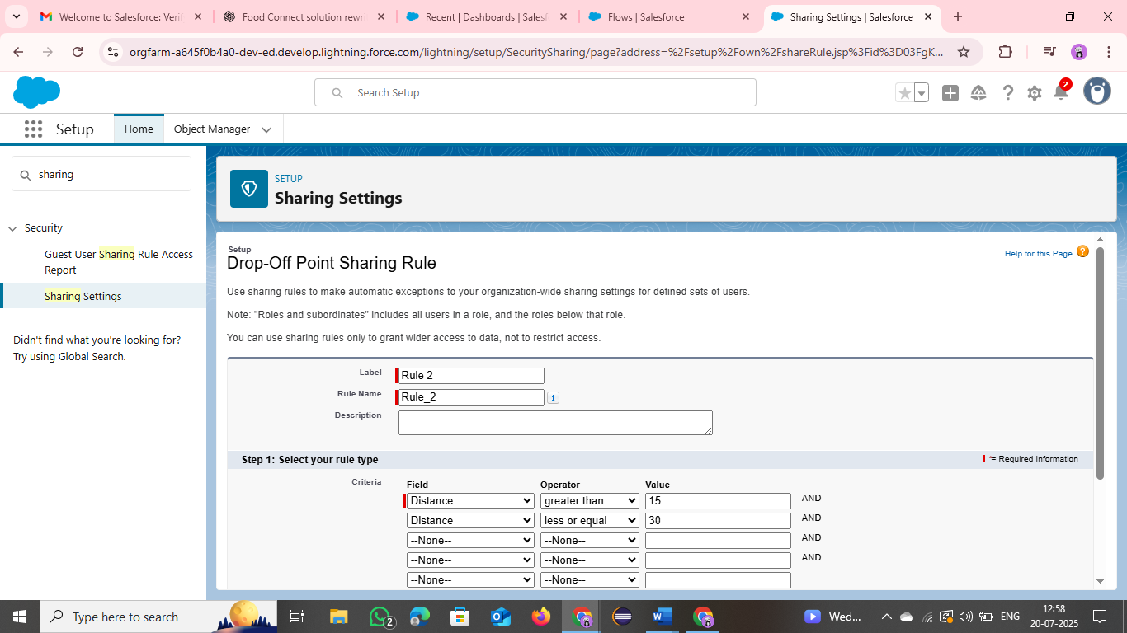

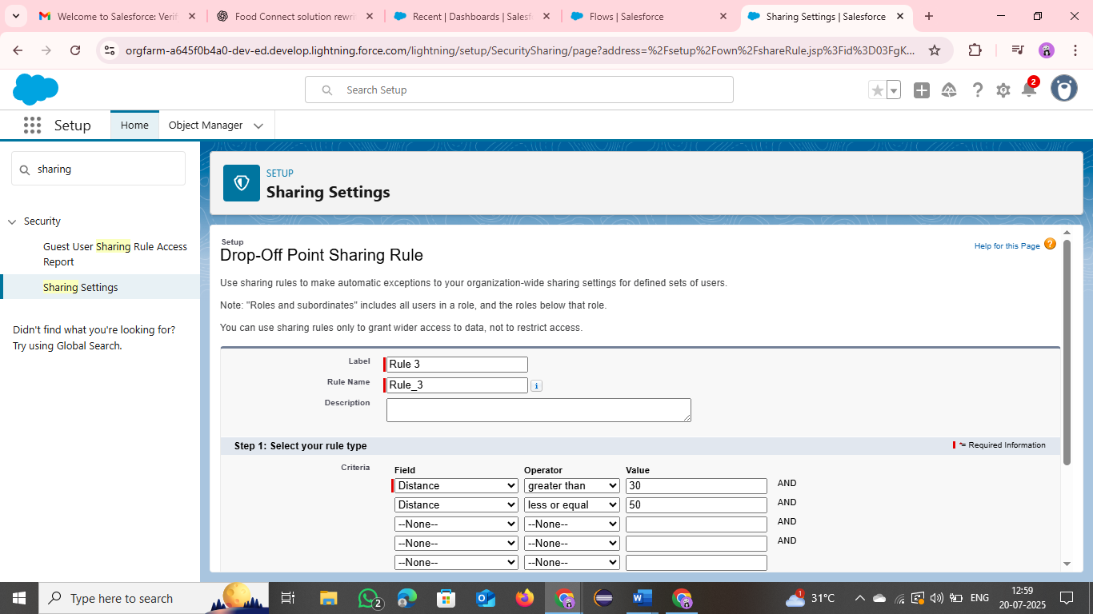

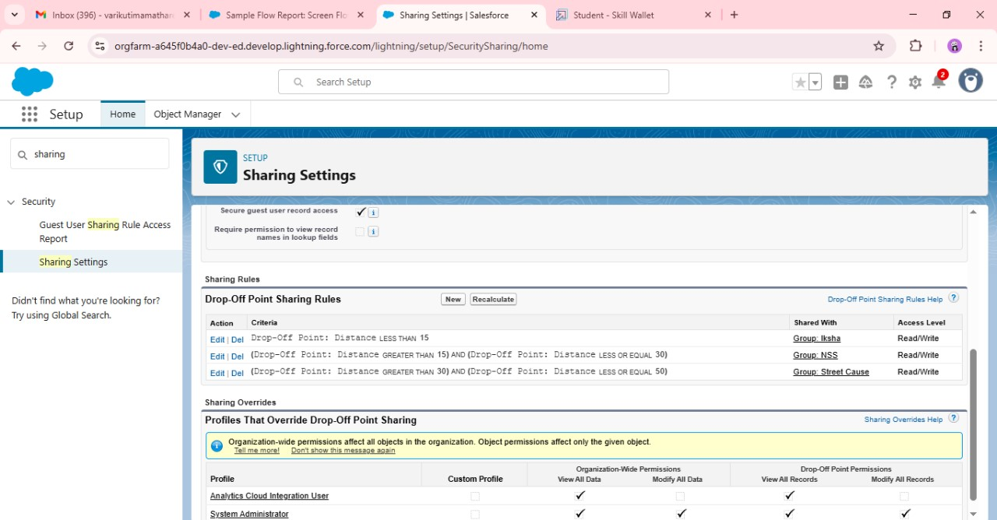

**PHASE – 5 :Deployment , Documentation & Maintenance :**

This is the final step in the project lifecycle.

* The app **Food Connect** is added to the app launcher to create the homepage.
* Post-deployment, visual content such as photos of activities, daily updates, and lists of donors (if they consent) can be uploaded to maintain transparency and build trust.
* Continuous improvements and documentation updates help keep the app relevant and functional.

After connecting the Food Connect app to app defaulter the home page will be generated and it will look like this.

We can in addition also add a few pictures related to the work we do and with that we can update it day to day by adding more information like our day to day work pictures details of what we do with that we can also add the donor names if they are willing.

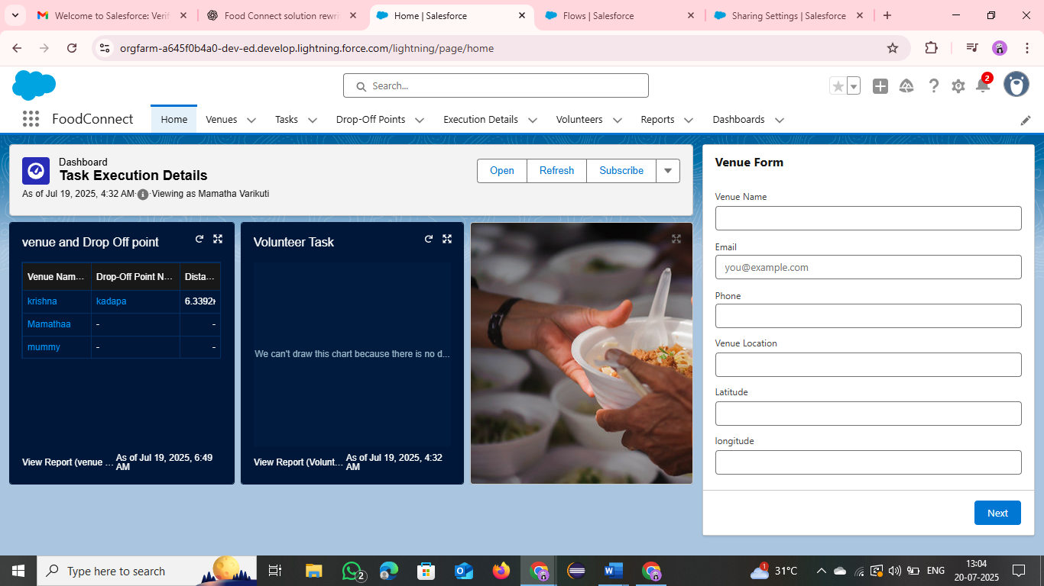

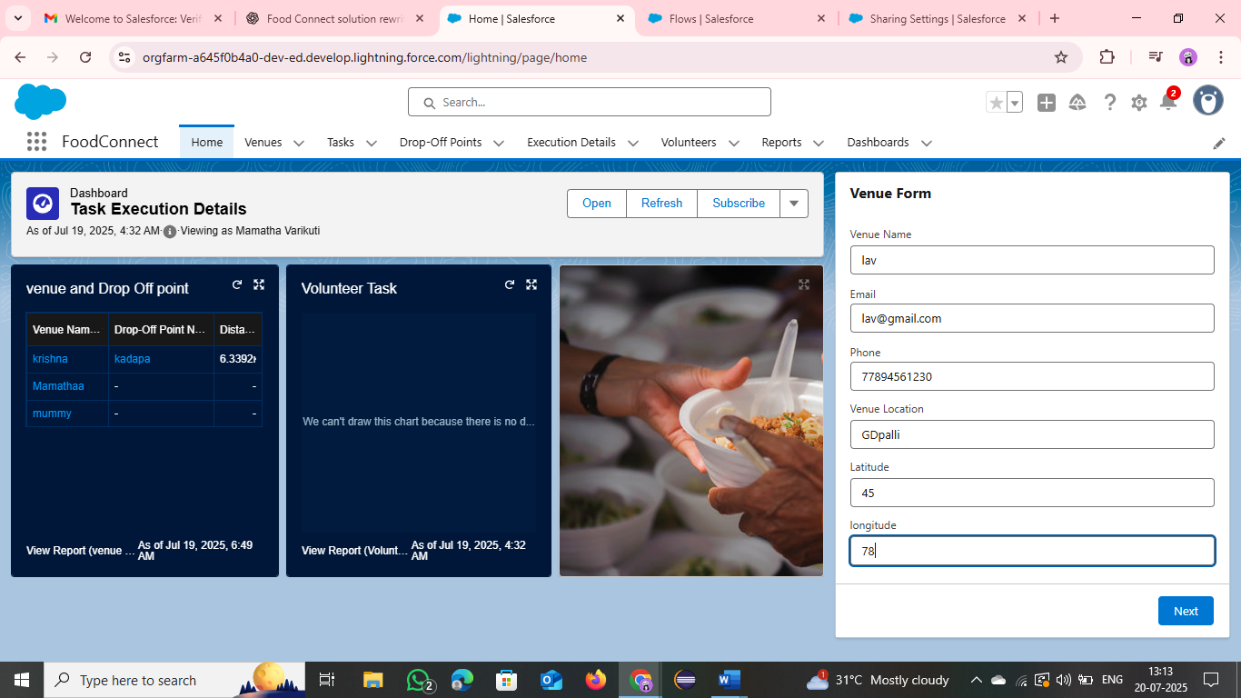

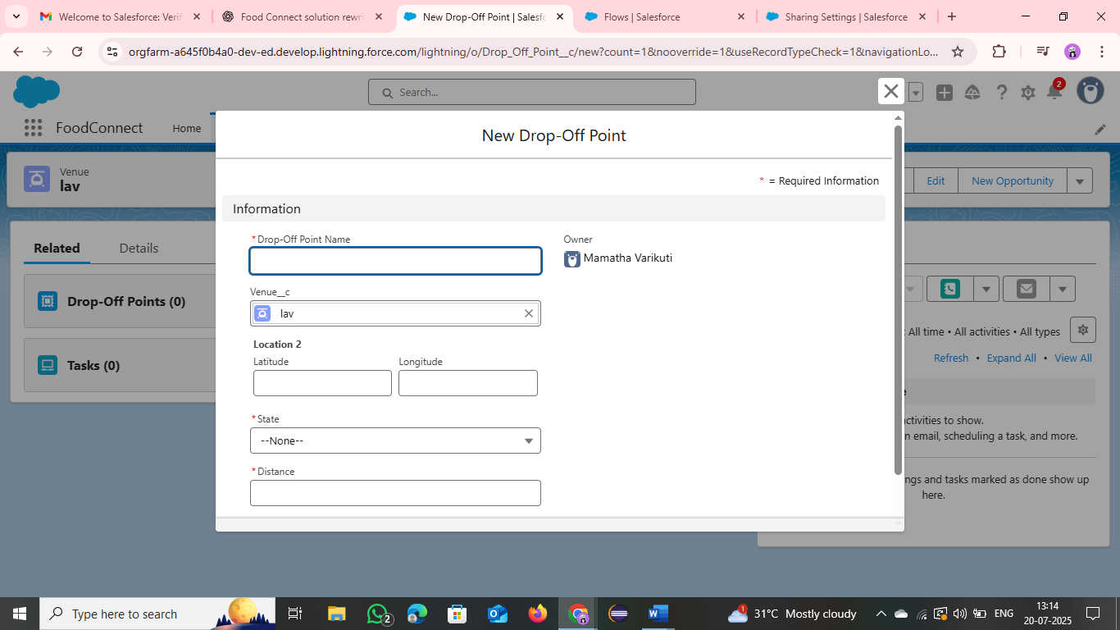

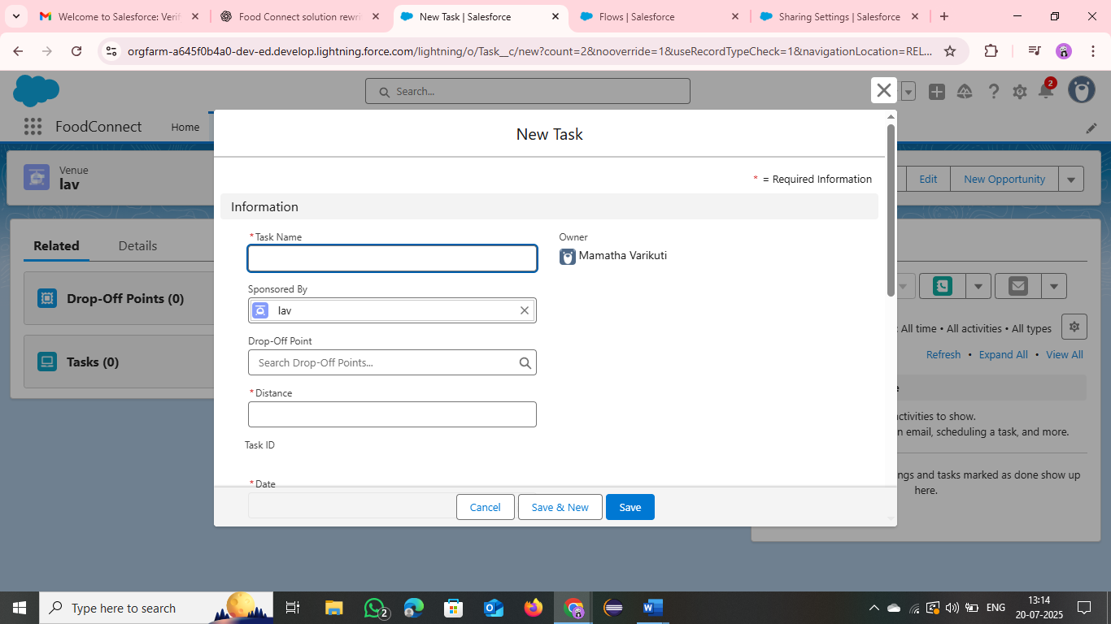

**CONCLUSION :**

The Salesforce Food Connect App effectively streamlines the food distribution process by utilizing Salesforce’s powerful features. It boosts coordination among volunteers and donors, ensures transparency, and helps tackle food insecurity while making the best use of available resources.

**Summary of Project Achievements:**

* **Outcome**: A fully working Salesforce-based app that improves the efficiency of food distribution.
* **Impact**: Better coordination and clear visibility into food donation and delivery activities.

ADDITIONAL DETAILS :

An enhancement idea for the app is the integration of **Artificial Intelligence (AI)** to improve user experience and functionality.

* AI can assist new or less tech-savvy users in navigating the app and understanding its features.
* It can provide voice-guided support to help users learn how to register as volunteers or donate food.
* AI can offer quicker and more accurate directions for volunteers to reach donation or distribution locations.
* Additionally, it can enhance security by detecting suspicious activity or preventing unauthorized access to the app.